5-Day Amazing Wildlife & Gorilla Trekking Safari
Overview
This gorilla and Wildlife safari takes you to the impenetrable forest of Bwindi, a UNESCO Heritage Site for gorilla trekking. You will also visit Queen Elizabeth National Park where you will enjoy the Kazinga channel boat safari and Lake Mburo National Park for a unique Walking safari inside the park. Enjoy scenery viewing as you travel.

Route
Start & EndDay 1Day 2-3Day 4
Uganda
Start | Entebbe (Day 1)
Day 1 | Queen Elizabeth NP
Day 2-3 | Bwindi Impenetrable NP (Gorillas)
Day 4 | Lake Mburo NP
End | Entebbe (Entebbe) (Day 5)

Tour Features

Mid-range tour
This mid-range tour uses lodges.

Private tour
This tour will be organized exclusively for you and won't be shared with others.

Can start any day
If availability permits, this tour can start on any day.

Can be customized
You can request changes to this tour.

Suitable for solo travelers
Solo travelers can book this private tour.
15

Minimum age of 15 years
The minimum age for this tour is 15 years.

Activities & Transportation

Activities: game drives, gorilla trekking & boat trip

Game drives: pop-up roof 4x4 vehicle

Getting around: pop-up roof 4x4 vehicle, boat & hiking/walking

A transfer from and back to the airport is included

Accommodation & Meals
- Additional accommodation before and at the end of the tour can be arranged for an extra cost
- Day
Accommodation
Meals
- 1
Elephant Hab LodgeMid-range lodge just outside Kyambura Gorge (Chimps)

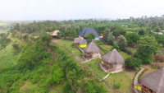

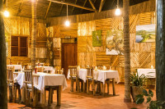

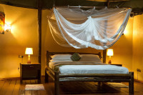

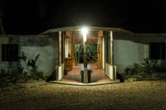+7Photos

Lunch & Dinner Included
- 2-3
Bweza Gorilla LodgeMid-range lodge just outside Bwindi Impenetrable NP (Gorillas)

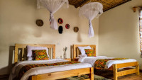

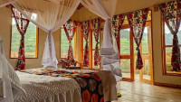

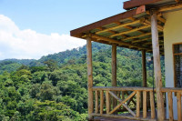

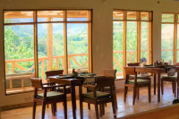

All Meals Included
- 4
Rwakobo Rock LodgeMid-range lodge just outside Lake Mburo NP

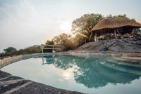

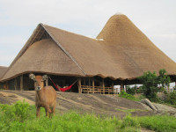

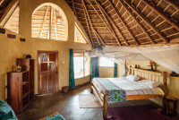

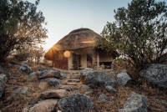+6Photos

All Meals Included
- 5
End of tour
(No accommodation)
All Meals Included

Day by Day

Arrival
- You'll be collected from the airport.
- Accommodation before the tour starts can be arranged for an extra cost.
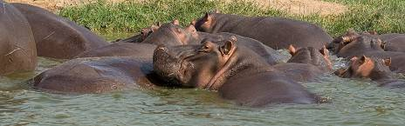

Day 1

Transfer to Queen Elizabeth National Park
You will transfer to Queen Elizabeth National Park starting early morning, Lunch will be served at the lodge and you will have a boat safari at 4pm, the kazinga boat is one of the best experiences in East-Africa offering you many opportunities to spot wildlife as they cool off days heat and prepare for their night, check in at the lodge and rest.
Main Destination:
Queen Elizabeth National Park
Best Time To VisitJanuary to February and June to July (Dry seasons)
High SeasonJune to September (Peak time for Uganda)
Best WeatherJune to July and January to February (Less rainfall)

Wildlife in Queen Elizabeth NP
ChimpanzeeOccasional

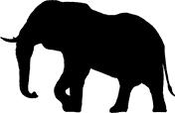
ElephantCommon


LionCommon


BuffaloCommon


HippoAbundant


LeopardOccasional

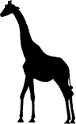
GiraffeNone


White RhinoNone


Black RhinoNone


CheetahNone

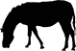
ZebraNone

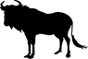
WildebeestNone


Wild DogNone
Accommodation:
Elephant Hab Lodge
- Mid-range lodge located just outside Kyambura Gorge (Chimps)







+7Photos

Meals & Drinks:
- Lunch & dinner (Breakfast not included)
- Drinking water (Other drinks not included)
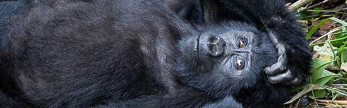

Day 2

Transfer To Bwindi Impenetrable National Park
You'll have breakfast early in the morning and thereafter, go for a morning game drive, drive through the Ishasha Sector for a chance to see the Tree Climbing Lions, Continue to Bwindi.
The drive to Bwindi is long but rewarding with panoramic views of the green vegetation and traditional homesteads. You will check in at your lodge and rest over night.
Main Destination:
Bwindi Impenetrable National Park (Gorillas)
Best Time To VisitJune to August and December to February (Gorilla trekking is easiest)
High SeasonJune to September (Gorilla permits are scarce)
Best WeatherJune to July and December to February (Less rainfall)

Wildlife in Bwindi Impenetrable NP

GorillaCommon

ChimpanzeeRare


ElephantRare


White RhinoNone


Black RhinoNone


LionNone


GiraffeNone


LeopardNone


CheetahNone


BuffaloNone


ZebraNone


WildebeestNone


HippoNone
Accommodation:
Bweza Gorilla Lodge
- Mid-range lodge located just outside Bwindi Impenetrable NP (Gorillas)









Meals & Drinks:
- All meals included
- Drinking water (Other drinks not included)
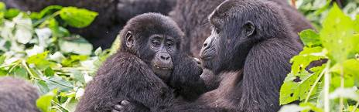

Day 3

Gorilla trekking experience
You'll enjoy a heavy morning breakfast then drive for 10 minutes to the park headquarters for briefing about the do's and don'ts' of Gorilla Tracking. Gorilla trekkers enjoy the most exciting and memorable activity of trekking the mountain gorillas in the thick jungle. The time spent trekking depends on the movement of these gorillas, it’s about 2 to 8 hours. Before you start the trekking you should expect to hike for a long distance under muddy and steep conditions before seeing the great apes in the Jungle. The gorilla trekking experience is obviously rewarding as you watch them, play and eat. To protect the gorillas and visitors, everyone is required to wear a face mask. After trekking you will return to your lodge.
Main Destination:
Bwindi Impenetrable National Park (Gorillas)
Accommodation:
Bweza Gorilla Lodge
- Mid-range lodge located just outside Bwindi Impenetrable NP (Gorillas)
Meals & Drinks:
- All meals included
- Drinking water (Other drinks not included)
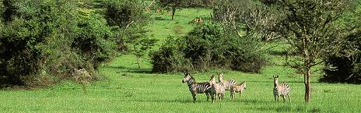

Day 4

Transfer To Lake Mburo National Park
You'll have morning breakfast at your lodge and then start your transfer to Lake Mburo National Park. On arrival at Lake Mburo National Park, you will enjoy an evening game drive where you will be able to view many animals including the Impalas, buffalos, leopards, Giraffes, Zebras, birds and many more. There is an option for a night game drive. You will later check in at your lodge for an overnight stay.
Main Destination:
Lake Mburo National Park
Best Time To VisitJanuary to February and June to August (Dry seasons)
High SeasonJune to September (Peak time for Uganda)
Best WeatherJune to August and January to February (Little rainfall)

Wildlife in Lake Mburo NP

GiraffeCommon


BuffaloCommon


ZebraCommon


HippoCommon


LeopardOccasional


HyenaOccasional


ElephantNone


White RhinoNone


Black RhinoNone


LionNone


CheetahNone


WildebeestNone


Wild DogNone
Accommodation:
Rwakobo Rock Lodge
- Mid-range lodge located just outside Lake Mburo NP







+6Photos

Meals & Drinks:
- All meals included
- Drinking water (Other drinks not included)
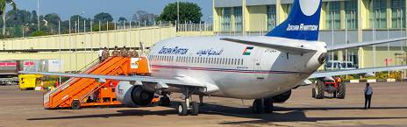

Day 5

Transfer to Entebbe International Airport
You will wake up early in the morning, a cup of coffee and go for one of the unique activities in Africa, The Safari walk offers you great opportunities to walk with the wildlife in the wilderness, you connect with nature and walk among the wildlife, you will have an armed park ranger walk with you for 2 hours, this is very exciting and special activity, After return to the lodge for late breakfast and check out, stop for lunch at the Equator and later proceed to Entebbe, Kampala or Entebbe International Airport. This will be the end of your amazing 5 days tour.
Main Destination:
Entebbe International Airport (Entebbe)
Accommodation:
No accommodation (End of tour)
Meals & Drinks:
- All meals included
- Drinking water (Other drinks not included)

End of tour
- Additional accommodation can be arranged for an extra cost.
- You'll be dropped off at the airport.

Rates

Important to Know
- Rates are per person and exclude the international flight from/to your home country.
- This tour accepts children who are 15 years and older.

Rates Per Person
Start dates | Solo1 room | 2 people1 room | 3 people2 rooms | 4 people2 rooms | 5 people3 rooms | 6 people3 rooms
Jan 1, 2025 - Dec 31, 2025 | $2,891 | $2,090 | $1,891 | $1,782 | $1,713 | $1,650
Jan 1, 2026 - Dec 31, 2026 | $2,891 | $2,090 | $1,891 | $1,782 | $1,713 | $1,650
Jan 1, 2027 - Dec 31, 2027 | $2,891 | $2,090 | $1,891 | $1,782 | $1,713 | $1,650

Inclusions

Included
- Park fees(For non-residents)
- Gorilla permits(One per person, non-resident)
- All activities(Unless labeled as optional)
- All accommodation(Unless listed as upgrade)
- A professional driver/guide
- All transportation(Unless labeled as optional)
- All Taxes/VAT
- Roundtrip airport transfer
- Meals(As specified in the day-by-day section)
- Drinking water(On all days)

Excluded
- International flights(From/to home)
- Additional accommodation before and at the end of the tour
- Tips(Tipping guideline US$10.00 pp per day)
- Personal items(Souvenirs, travel insurance, visa fees, etc.)
- Government imposed increase of taxes and/or park fees

Interested in This Tour?

